1. **Product Discount Calculator with URL in the browser**

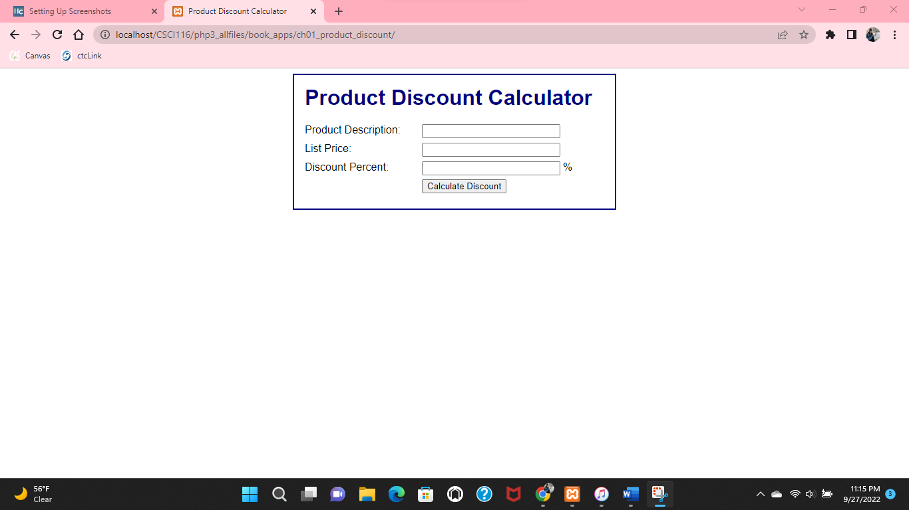

1. **Future Value Calculator with URL in the browser**

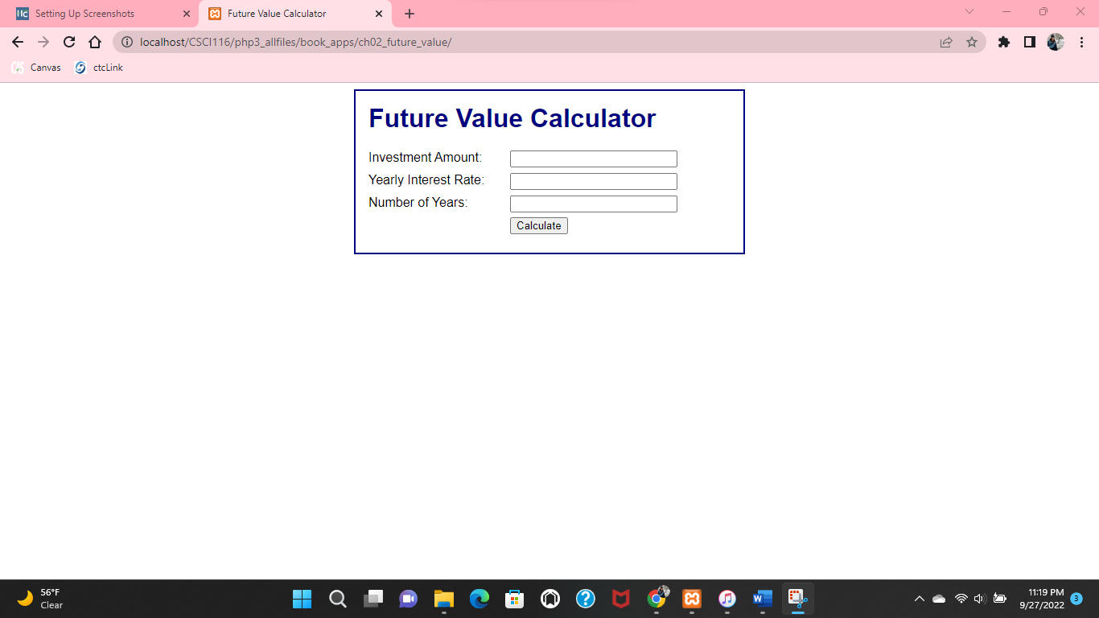

**3. Vscode displaying 3 open files and the first 12 lines of code**

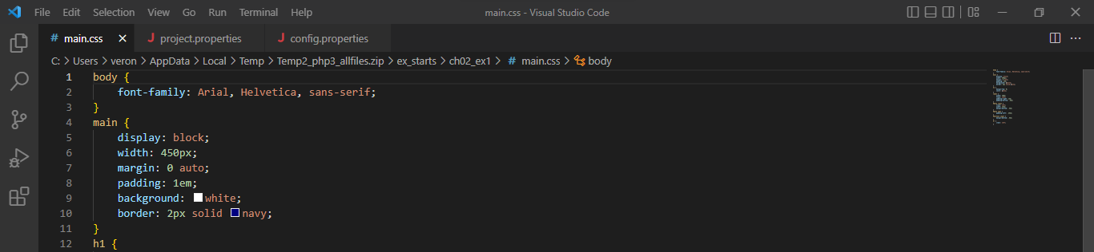

**4. Screenshot of CSCI 116 folder in Xampp > htdocs > CSCI116**

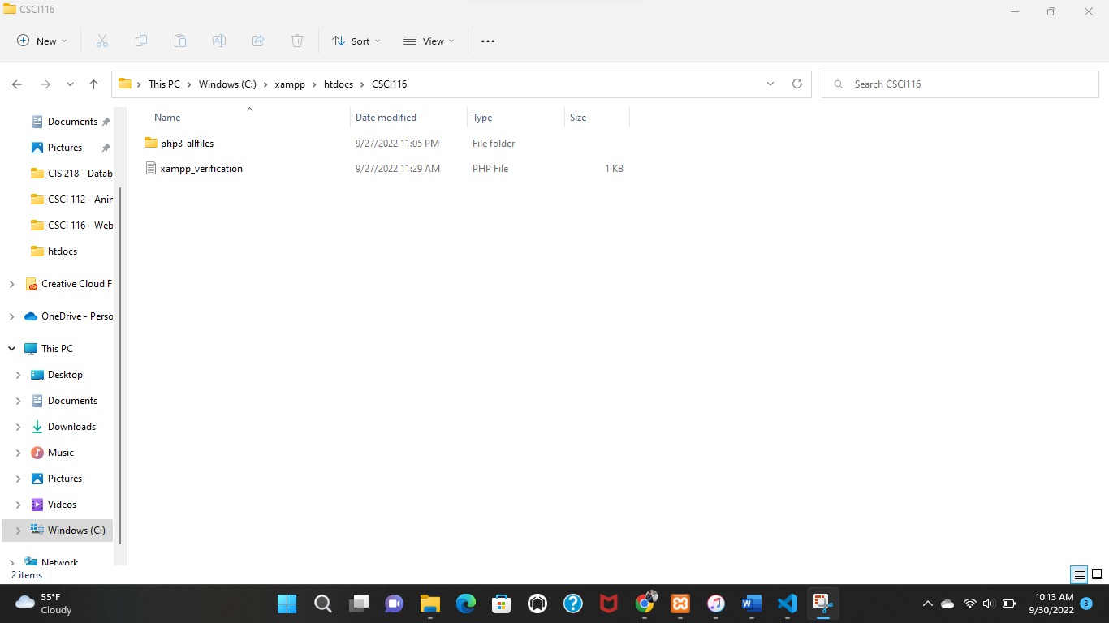

**5. Displaying CSCI 116 folder on the left panel as local file on Xampp. On the right panel displaying CSCI 116 folder on the Chelan server.**

